



PT. SINKO PRIMA ALLOY
Alamat : Jl. Tambak Osowilangun Permai No. 61,
pergudangan osowilangun permai Blok E7-E8,
Surabaya-Indonesia (60191)
Telepon : 031-7482816
Fax. : 031-7482815
Aftersale (WA) : 0821-4281-7085
Email : aftersales@elitech.co.id
sinkoprima@gmail.com
Website : www.elitech.id

SPA-BM/PROD-227. 04 August 2025. Rev00

SOZ-YB-35G
OZONE GENERATOR
Booklet of directions
titanium des-hydroxy quartz structure
- Not giving birth to the ozone the warning
- The backwater warning
- The machine breaks down the warning
- The temperature overtops the warning and stop the machine
- The device occurs high yield capacity ozone
- Ozone consistency ca adjusted

Attention : The machine sould be installed in the ventilation dryly and the clean place Place rigorously enforce according to installing the bocklet of directions installiation, in order to prevent the backwater Interval time driving the machine 2 times should be more than 5 seconds Place keep the clean of machine, and pays attention to the waterproof dampprofing, with Life span that lengthens the machine.

Request the detail to read the booklet of directions before installing the use

Structure and feature
Parameter | Spesifikasi
Type | SOZ-YB-35G
Power | ±470W
The use power supply | 220V
The work temperature | < 40°C
Size | 65,5 x 62,5 x 120 Cm
Weight | 44 kg
Current | ±1.65 A
Output Flow | 5-10 L/min
O₃ Concentration | 80-100 g/m³
Ozone Output | ± 35 g/h

Featyre
Strong power ozone generator SOZ-G using the titanium des-hydroxy quartz endureing high temperature structure discharge cell (big ring patent product) this structure uses the most stablely and service life is long, and possesses that the such as damage etc.
- Not giving birth to the ozone the warning. The not automatic stop. There has he Recovering behind the ozone to be normal. This merit can be showed the whether normal work of discharge cell. The following circumstances is not had ozone not reporting to the police: CD There is not the electricity aspect to import; @ me gas pipeline stops up or leaks. Ozone consistency relates with the input ga source, and it is the biggest during input oxygen, importing the dry air taking second place.
- The backwater warning. Stopping the machine drives the machine with oxygenor dry air after blowing the trunk, and drives the machine closing stopping in 3 second reporting to the dry air taking second place.
- The temperature overtops the warning and stop the machine when following of temperature 50 degrees recovers work and stop warning. The cause of this circumstances has appeared : CD The electric fan net has stopped up @2 The fan is bad (3 The environment temperature overtops.
- Report to the police hence the circuit has appeared to hinder 4.

Component
- The generator cell
- The stainless steel
- Outer covering
- Electric metre
- 150 electric fans
- Appendix : 220V' s one on thread power supply Ozone pipeline 8-10M

WARNING : Not open the envelope during non-profesional person or the circular telegram State, in order to avoid the high pressure wounds

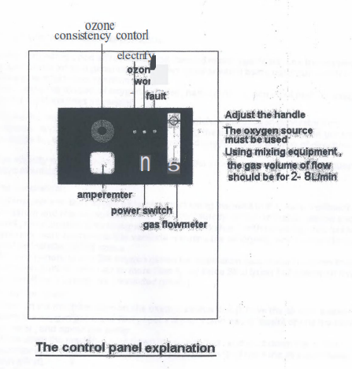

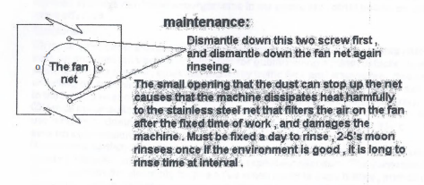

Being used pays attention to the item:
- Please for getting good effect destroying harmful microorganisms, use the oxygen of oxygen or the oxygen generator of oxygen cylinder when being used pure water to destroy harmful microorganisms. When using the oxygen of oxygen cylinder, namely the oxygen input port on oxygen and the machine links passablely.
- Please that my corporation provides is well matched the oxygen generator that overlaps, and asks aboutthe purchase. Usingthe oxygen thatthe oxygen generator gave rise to, the connected graph is consulted and follow his booklet of directions.
- For stability and long-term life span pledging the product, the special user requesting pays attention to the following item:
- The installation
CD Generator and the oxygen generator must being installed in the water treatment workshop and loading outside the workshop (strictly forbids to install narrow and small, moist system Shui Huoguan loads the workshop) with irrigating, and keeps the generator work environmentto ventilate reaching the air-drying, and the ventilating fan must be installed in this space. 2 Ozone generator and the oxygen generator installation seat should be more than 1.2 meters on ground, and can be more than to lay aside Shui Guan 1-2 rice when having the condition. (seeing the connected graph)
- The use program
CD Turn on the machine: turn on the oxygen source first (if have the air compressor, opens the oxygen generator first, opens the air compressor again) opens the ozone generator, and opens the pump. Shut down the machine: shut down the pump first, and shut down the ozone generator again, again shut down the oxygen generator (if have the air compressor,shut down itfirst). 3 Reducing this operation sequence during the anhydrous pump during other uses such as destroys harmful microorganisms in the space etc, other operation sequence is same effective
- Maintenance CD Hence what causes becauseof the generator quality it self hinders, this corporation or sells on commission trade is responsible for guaranteeing against defects, and need to come to see the service, customer must pay traffic fees and staying fee, this corporation or selling on commission trade decides travelled, and especially exceptthe appointment. 2 Hence the unsuitable generator that what causes of the external world or human factors or use hinders or damages, the material fee can suitably be receiveed in this corporation or sells on commission trade.
- It is many partially that what causes hence becauseof too moist or a large number of intaking hinders, and should cause user's especially attention. The generator can be the warning when generator pipeline is intake, and should stop the machine, and open thatthe oxygen source blows blowing dry water, until stopping to report to the police. (simple 30 minutes)
- The due appointed man of user safeguards and manage

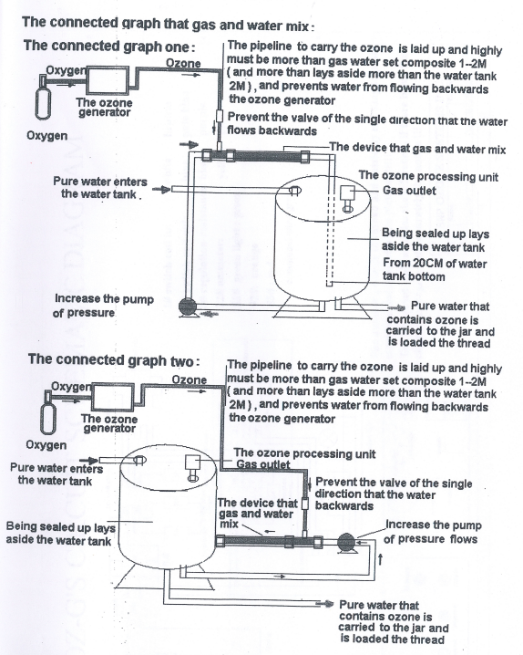

OZONE GENERATOR
SOZ-YB-32G



MANUAL BOOK

